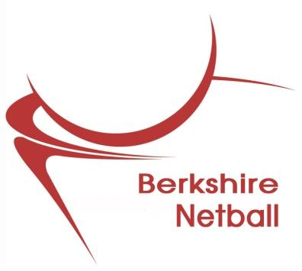

Berkshire Netball
Annual General Meeting
A G E N D A
Thursday 26 August 2021
7.30pm
via Zoom

- Apologies for Absence

2. Minutes of last AGM – July 2020

- Matters Arising

- Adopt Officers' Reports:- Chairperson
Competitions
Coaching
Umpiring
Development
Treasurer
Publicity
Events
Berkshire NDO

- Adopt League Reports:- Ascot (Charters Triple SSS)
Bracknell
Maidenhead
Newbury
Berkshire Premier
Reading

- Adopt accounts and reports

- Election of Officers

7. Any Other Business

